Raise awareness, save lives!

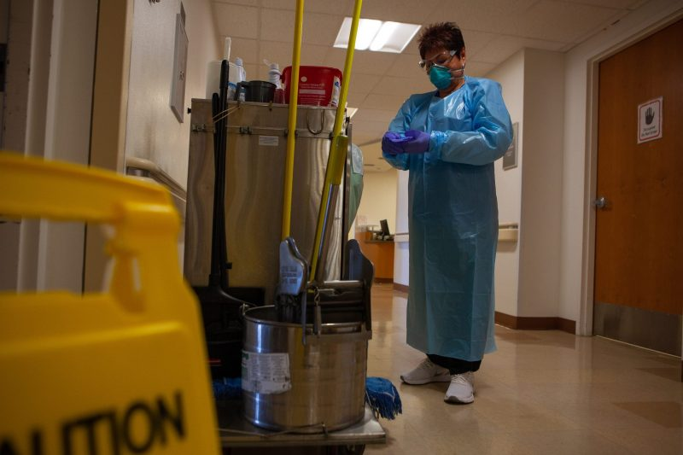Forcing someone to work against their will, often without pay and taking away their freedom, is modern slavery.

Having no personal identification or being unable to communicate freely can also be signs or ‘flags’ of modern slavery.

In healthcare, this can mean workers are overworked and unable to leave their job.

**Did you know**

* Over 1,900 people in Australia are victims of Modern Slavery.
* In Australia, only 1 in 5 modern slavery victims are detected.
* The Australian Federal Police (AFP) received more reports of Modern Slavery in 2023-24 than in any other financial year.

**To report modern slavery in Australia:**

* Contact the AFP on 131 237 or online at www.afp.gov.au
* For free, confidential legal advice, contact Anti-Slavery Australia on 02 9514 8115 or visit [www.antislavery.org.au](http://www.antislavery.org.au)

**www.healthsharevic.org.au**