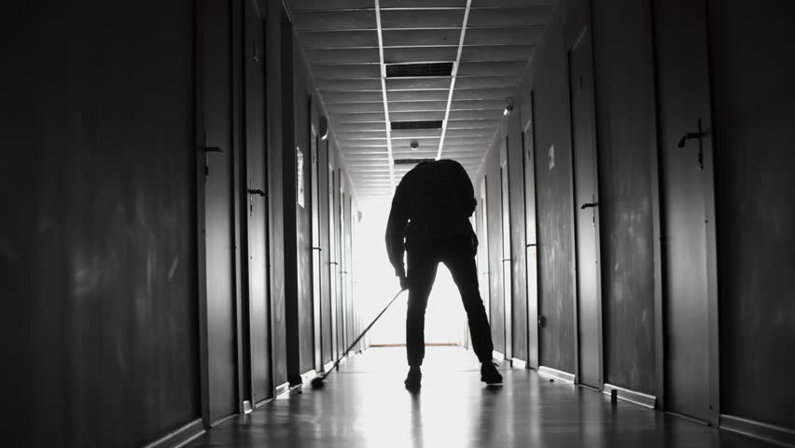Act for their safety

No matter where we come from, we all want our loved ones and our community to be safe from harm and free from exploitation.

Do you know someone who is being made to work against their will, in a situation that is unsafe, with poor or no pay?

They may be forced to stay with their employer and are being physically abused. Your action can change this.

Making someone work under conditions that mean they are being exploited is modern slavery. In Australia, only one in five people are saved. You can change this and help them be safe.

**Help make a difference and report modern slavery today**

Contact Anti-Slavery Australia for a free, confidential discussion on 02 9514 8115 or visit their website at [www.antislavery.org.au](http://www.antislavery.org.au)

You can also contact the Australian Federal Police on 131 237 or submit a report online at [www.afp.gov.au](http://www.afp.gov.au)

If you have experienced exploitation in the form of modern slavery you can contact Additional Referral Program Monday to Friday during business hours on 1800 000 277.

If you think you or someone you know is in immediate danger call 000.

**www.healthsharevic.org.au**