Position | Lawyer
Reports to | General Counsel
Direct reports | Nil
Band classification | Band 5, HealthShare Victoria Enterprise Agreement 2024
Date approved | April 2025

- HealthShare Victoria
HealthShare Victoria is a Victorian public sector entity established on 1 January 2021 as an independent, commercially oriented public sector provider of supply chain services (surety, procurement and logistics) to Victoria's public health sector.
Our purpose is to partner with Victoria's public health services, suppliers and government to ensure the right products and services are delivered to the right place at the right time, supporting better value for our public health services and better outcomes for their patients.
We work with Victoria's public health services to understand their requirements. We meet these needs by establishing collective agreements (purchasing contracts) for medical consumables, pharmaceuticals and medical equipment, as well as non-medical products and services they need via large-scale tenders.
We also play a critical role in ensuring Victoria's public health services have access to goods and services that may be in higher demand or difficult to access, including personal protective equipment (PPE), medical consumables, ICU equipment and pharmaceuticals.
We administer several compliance-related functions, and work with health services to assist them in meeting their legislative, compliance and probity obligations.
As well as providing an end-to-end health supply chain for Victoria's public health services, we extend access to our collective agreements to health or related services assessed as 'eligible services'.
Building on a spirit of change and transformation, our work supports our health service customers to deliver safe, high quality and sustainable healthcare for all Victorians.
- Position summary
The Lawyer is responsible for supporting the operations and legislative functions of HealthShare Victoria (HSV) with the provision of legal advice and legal services including investigating complaints and freedom of information (FOI) requests.
    - Provide practical and strategic advice on legal issues, including a sound understanding of administrative law, the tender process, probity, and contract law.
    - Assist in contract drafting and negotiations while demonstrating commercial acumen and an appreciation of government decision-making principles.
    - Supporting the legal compliance framework within HSV.
    - Support HSV in responding to FOI requests.
    - Assist in the promotion of risk management principles across the organisation.
    - Establish and manage strong relationships with key internal and external stakeholders
- Specific duties and accountabilities

Legal Advice and Data Management
- Assist in the review, drafting and negotiation of contracts based on procurement policies and procedures, best practices and case law.
- Provide legal and strategic advice to internal clients and stakeholders and where necessary, obtain external legal advice, including in relation to HSV’s legislative and regulatory obligations.
- Stay up to date with legal and regulatory changes affecting the organisation and Victorian public health sector.
- Assist staff compliance with legal requirements and HSV policies and frameworks by assisting in the development and implementation of training and guidance to staff.
- Assist in the assessment of and response to requests for information, including requests under the Freedom of Information Act and by regulatory bodies.
- Draft legal templates and tools to be leveraged by the Finance Risk and Governance division as well as internal and external stakeholders as required.
- Develop, maintain and implement policies, procedures and practices to manage legal risks of HSV and ensure compliance with HSV’s legislative and regulatory obligations.

Legislative Compliance
    - Proactively engage the broader organisation on compliance matters, reinforcing the importance of shared ownership and driving a culture of compliance.
    - Providing legislative compliance advice and implementing controls relating to HSV’s compliance with legislative and regulatory obligations.
    - Maintain regular communication with compliance obligation owners to enhance understanding of their compliance responsibilities and the use of the compliance management system.
    - Administer HSV’s legislative compliance management system, including monitoring alerts, running reports and engaging with obligation owners regarding use of the system.
    - Prepare compliance reports for management including the General Counsel, Executive Leadership Team and the Board (including Board sub-committees).

Risk Management and Reporting
    - Assist in the application of Probity policies and procedures, including provision of probity advice to internal clients.
    - Conduct investigations by reviewing complaints, identifying issues, obtaining evidence and drafting comprehensive investigation reports with findings and quality improvement recommendations.
    - Provide a range of reports to inform decision making including work progress, workflow projections and legal budget expenditure.
    - Support internal audits to ensure that staff are compliant with legislative and regulatory obligations, including implementation of relevant action plans

Health, Safety and Wellbeing (BeSafe)
    - Follows safety rules and takes responsibility for safety at a personal and team level to reduce risk to others
    - Reports hazards, incidents and injuries and takes part in actions to eliminate hazards
    - Shows a sense of urgency when safety issues arise
    - Makes safety a part of the everyday by talking about ideas for improvement
    - Attend BeSafe activities, forums and training to help create a robust safety culture at HSV

HSV Values
Uphold the HSV values:
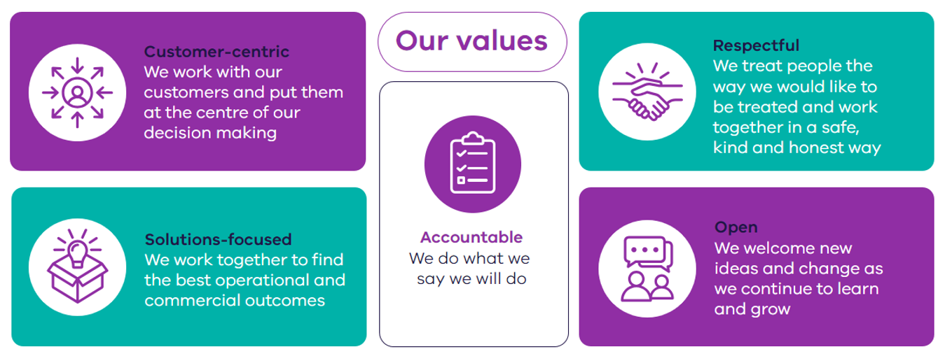

Collaboration at HSV
    - Builds and maintains effective collaborative and consultative working relationships
    - Listens and works as a supportive and cooperative team member, sharing information and acknowledging others’ efforts
    - Has challenging conversations as required within scope of role and personal accountabilities
    - Steps in to help others where required.

HSV Strategy, Policies and Procedures
    - Contribute to the delivery of HSV’s strategic plan and roadmap initiatives.
    - Comply with HSV policies and procedures and report breaches and/or risks to your people leader or another relevant stakeholder.

Other duties
    - While the principal duties are detailed above, this position may be required to undertake other duties from time to time.
- Qualifications and experience required

Academic
    - Law Degree with admission to the legal profession
    - Victorian Practising Certificate or an ability to obtain

Experience
    - At least 3 years post qualification (or other relevant) experience.
- Demonstrated experience in contract law and drafting and negotiation of commercial agreements, ideally in relation to Government procurement.
- Experience advising in relation to regulatory and compliance matters.
- Proven experience in problem solving and display of sound judgement and resilience

Personal
    - Excellent written and verbal communication skills.
    - Ability to work productively under time pressures while managing multiple tasks.
    - Strong attention to detail and organisational skills.
    - Strong ‘team builder’ with the ability to develop and maintain positive working relationships with people at all levels within and outside the organisation.
    - Ability to work positively within a team to deliver best practice outcomes and shared goals.
    - Inquisitiveness, initiative and innovative thinking.
    - Ability to maintain and respect confidentiality.
- HSV’s Leadership Capability Framework

Everyday leaders
Everyday leaders are motivated and passionate about HSV’s work and committed to delivering their work efficiently and to a high standard. They take responsibility for getting the job done and seek opportunities to collaborate and to share or gain knowledge. They understand how their work fits into HSV’s strategy and are committed to the organisational vision.
Priority leadership capabilities for everyday leaders:
- Problem solver – Demonstrates problem solving within scope of role. Develops useful, workable and practical solutions to address issues, shows initiative, gets things done and owns the results.
- Operates with integrity – Acts honestly, is professional and lives HSV values
- Works collaboratively - A team player who values all contributions and works jointly with others (internally and externally) to deliver results
- Health and safety - Sets expectations and takes responsibility for a physically and psychologically safe culture and work environment
- Locations for work
Primary:
- CBD Office: 11/50 Lonsdale Street, Melbourne VIC 3000
Secondary:
- Derrimut Distribution Centre: Foxley Court Derrimut, Victoria; and
- Dandenong Distribution Centre: Ordish Road Dandenong South, Victoria.
- As relevant the position may be required to work from home from time to time.

