Procurement Strategy Template
Contents
Purpose 2
Procurement Objectives 2
Procurement Profile 2
Procuring for [health service] 2
Procuring on behalf of other health services 2
Governance Structure 2
Procurement Governance Framework 2
Roles and Responsibilities 3
Procurement Process 3
Procuring for [health service] 3
Procuring on behalf of other health services 3
Complexity Assessment Framework 4
Market Approach 4
Procurement Activity Plan 5
Supplier Engagement Plan 5
Capability Plan 5
Contract Management Strategy 5
Disclaimer 5
Appendices 6
Spend Categories at [health service] 6
Procurement Roles and Responsibilities 7
Disclaimer 7

Purpose
Enter details of your purpose statement(s) here.
Purpose Example
Our procurement strategy aims to provide guidance and support to employees for planning, sourcing and contract management of procurement activities to ensure compliance with internal procurement procedures (aligned to the HSV Purchasing Policies requirements) and the organisation objectives.

Procurement Objectives
Enter details of your organisational procurement objective(s) here.
Procurement Objectives Example
[Health Service] has established a strategic plan for 20XX-20XX. This plan includes a list of the procurement objectives for the organisation and is aligned to a strategic goal. The strategic plan can be found [enter location details].

Procurement Profile
Enter details of your organisational procurement profile here. Below are possible sub-headings to consider and may be applicable for your organisation.

Procuring for [health service]
Enter details of the procurement profile for your health service here.

Procuring on behalf of other health services
Enter details of the procurement profile for other health services here.

Governance Structure

Procurement Governance Framework
Enter details of your procurement governance framework here.
Procurement Governance Framework Example
Our procurement policy clearly defines our Procurement Governance Framework. There is a clear definition of accountability and auditability of all procurement decisions made within our organisation. The governance structure is flexible enough to purchase/source in a timely manner all goods and services required by the organisation and/or to be accessed. It also provides a means of monitoring policy compliance.

Roles and Responsibilities
Enter details of your organisational roles and responsibilities here.
Roles and Responsibilities Example
The roles and responsibilities listed [enter location], support procurement governance in the management of programs, projects and business operations to ensure compliance with our procurement policies (aligned to HSV PP requirements). The CE / Accountable Officer is responsible for establishing and implementing these roles to meet the needs of the procurement governance framework.

Procurement Process
Enter details of your organisational sourcing process here
Sourcing Process Example
The procurement process for [HEALTH SERVICE] is based on the types of sourcing that is undertaken by [HEALTH SERVICE]. Sourcing by [HEALTH SERVICE] for its own use is generally transactional with one of cases of extremely complex or risky procurement activity.
Below are some possible sub-headings to consider and may be applicable for your organisation

Procuring for [health service]
Enter details of the sourcing process for your health service here.

Procuring on behalf of other health services
Enter details of the sourcing process for other health services here.
You may also include illustrations of your sourcing process model.

Complexity Assessment Framework
Enter details of your complexity framework here.
You may consider including your organisational complexity matrix (if applicable). Below is an example:
Figure 1: Complexity Assessment Matrix
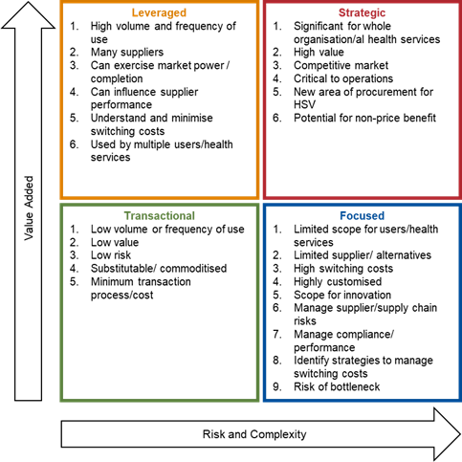

Market Approach
Enter details of your market approach strategy here.
You may consider including a table to show suggested market approach and probity requirements (if applicable). Below is an example:
Table 1: Recommended Market Approach Strategies
Complexity Assessment Quadrant | EOI | RFI | RFQ | RFT | RFP
Transactional  Probity – Auditor role may be required in limited cases | ☐ | ☐ | ☐ | ☐ | ☐
Leveraged  Probity – Auditor role applicable in some instances | ☐ | ☐ | ☐ | ☐ | ☐
Focused  Probity – Auditor and Advisor role in all instances | ☐ | ☐ | ☐ | ☐ | ☐
Strategic  Probity – Separate Auditor and Advisor in all instances | ☐ | ☐ | ☐ | ☐ | ☐

Procurement Activity Plan
Enter details of your procurement activity plan here
Procurement Activity Plan Tip
Enter description of what your procurement activity plan encompasses and where this document may be located.

Supplier Engagement Plan
Enter details of your supplier engagement plan here.
Supplier Engagement Plan Tip
Enter description of what your supplier engagement plan encompasses and where this document may be located.

Capability Plan
Enter details of your capability plan here.
Capability Plan Tip
Enter description of what your capability plan encompasses and where this document may be located.

Contract Management Strategy
Enter details of your contract management strategy here.
Contract Management Strategy Tip
Enter description of what your contract management strategy encompasses and where this document may be located.

Disclaimer
The information presented in this document is general in nature and based on HealthShare Victoria’s interpretation of the Health Services Act 1988 (Vic) and any ancillary legislation and regulations in effect at the time, and should not be relied upon as legal advice. Please consider seeking professional and independent advice from your legal representative as to the applicability and suitability of this information and the legislation to your own business needs or circumstances.

Appendices
Possible appendix entries may include:

Spend Categories at [health service]
Below is an example possible subset:
Table 2: Categories of Spend
Complexity Quadrant | EOI | RFI | RFQ
Corporate | Accountancy | $0.00 | 0.0%
 | Stationery and Suppliers | $0.00 | 0.0%
 | Audit Costs | $0.00 | 0.0%
Facilities | Cleaning | $0.00 | 0.0%
 | Electricity | $0.00 | 0.0%
 | Relocation Expenses | $0.00 | 0.0%
Staffing | Recruitment Expenses | $0.00 | 0.0%
 | Staff Training/Development | $0.00 | 0.0%
 | Staff Wellbeing | $0.00 | 0.0%
Continue for all relevant categories within your health service
 | Total | $0.00 | 100.0%

Procurement Roles and Responsibilities
You may consider including a table to show procurement roles and responsibilities at your health service. Below is an example format:
Table 3: Procurement Roles and Responsibilities
Roles | Responsibilities
Health Service Board | - Responsibility 1  - Responsibility 2
Health Service Committee 1 | - Responsibility 1  - Responsibility 2
Health Service Committee 2 | - Responsibility 1  - Responsibility 2
Health Service CE / Accountable Officer | - Responsibility 1  - Responsibility 2
Reference Group(s) | - Responsibility 1  - Responsibility 2
Continue for all relevant roles within your health service

Disclaimer
The information presented in this document is general in nature and based on HealthShare Victoria’s interpretation of the Health Services Act 1988 (Vic) and any ancillary legislation and regulations in effect at the time and should not be relied upon as legal advice. Please consider seeking professional and independent advice from your legal representative as to the applicability and suitability of this information and the legislation to your own business needs or circumstances.

The Procurement Strategy may consist of the above elements but may or may not be called the Procurement Strategy.
The PGF may consist of Policies and/or Procedures to make up the PGF but may/or may not be called the PGF.

