Exemptions Portal – Health Service Guide
Table of Contents
Introduction 1
Register on the HSV website 2
Accessing the Exemptions Portal 2
Exemption categories 4
Submitting an application 4
Endorsing an application (CEO/delegated authority) 5
Re-sending an application for endorsement 6
Accessing your existing applications 6
Application status 6
Assessment of the application 7
Responding to more information requests 7
Withdrawing an application 8
Exemption expiry 9
Support 9

Introduction
This guide outlines the steps required to manage an exemption application for a HSV contract via the online Exemptions Portal. The portal includes the ability to track/monitor the progress of an exemption application and receive reminder notifications for exemption expiries.
To access the exemptions portal, you will need to have a HSV website account. If you already have an account, go to the Accessing the Exemptions Portal section on page 3.
If you do not have an account, please register for one on the HSV website by following the instructions below to register on the HSV website.

Register on the HSV website
Click Register at the top right of the HPV Website (https://www.healthsharevic.org.au/)

Select I am a Health Service and enter your email address. Click next to continue to the next page,
complete all the required fields in the request form and submit the request.
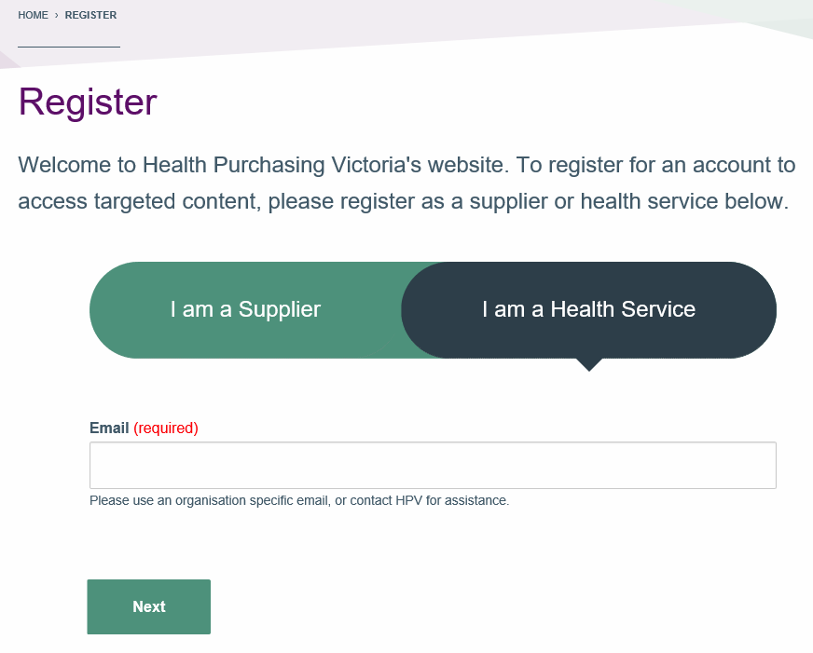
Please note, users applying for full registration (access to restricted content) on the HSV website will need to wait for their health service representative (super-user) to approve an account request before they can access other logged-in areas of the website.

Accessing the Exemptions Portal
To access the Exemptions Portal, sign in to the HSV website using your health service email address. Once you have logged in to the website, you will be re-directed to your user dashboard which contains quick links to other key areas of the website.

Click on the Exemptions link in the navigation menu on the left of the page to open the portal.
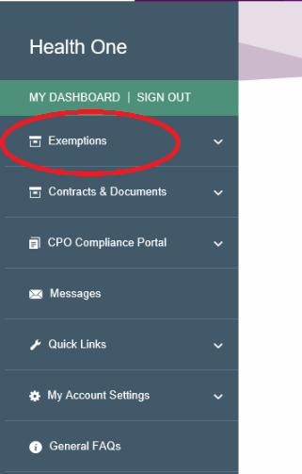
For more information on the HSV exemptions process click HERE.

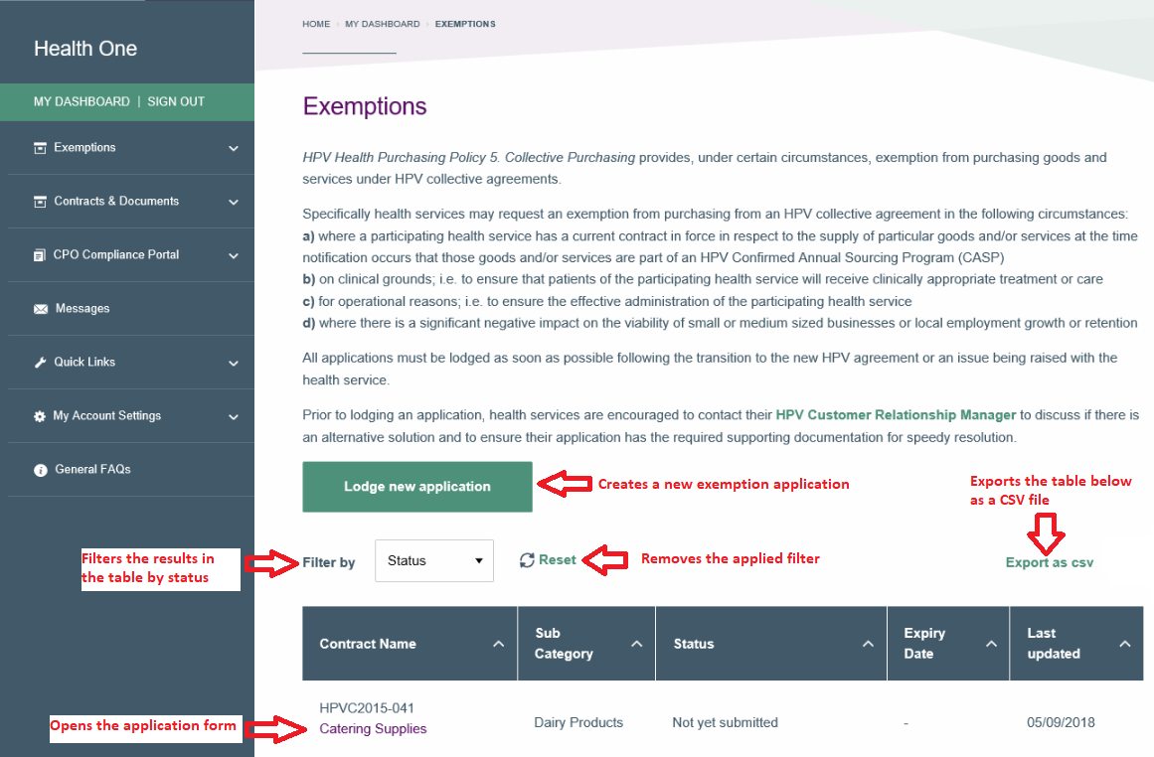
The image below shows the landing page of the Exemptions Portal.

Exemption categories
There are 4 exemption types available in the Exemptions Portal.
Type | Purpose
Type 1 – Pre-existing contract | Applying for an exemption due to an existing agreement between your health service and a supplier.
Type 2 – Clinical risk | Applying for an exemption based on clinical reasons
Type 3 – Operational risk | Applying for an exemption based on operational reasons
Type 4 – Impact on local business | Applying for an exemption based on a potential impact to a small- or medium-sized business or on local employment growth or retention.
The exemption form for Type 5 – on selling applications is not yet available in the exemptions portal but can be found on the exemptions page of the HSV website.

Submitting an application
To submit a HSV contract exemption application:
- Login to the Exemptions Portal on the HSV website
- Click Lodge new application to commence your application
- Select one of the four exemption types available
- Review the health service details section of the form and update if necessary
  - Updates to the position and department fields will backfill to your website profile
  - If health service name, email address or phone number is incorrect, please contact helpdesk@healthsharevic.org.au for assistance
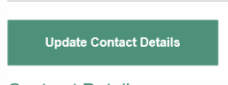
  - If the contact person for this application changes, the new contact person will require a HSV website account. The contact person can then login and click update contact details to update the contact person to themselves.
- Complete the remaining fields within the application form and ensure that all mandatory fields/attachments are filled in
- Submit the completed form for endorsement by your health service CEO/delegated authority
Once endorsed, the ap

Endorsing an application (CEO/delegated authority)
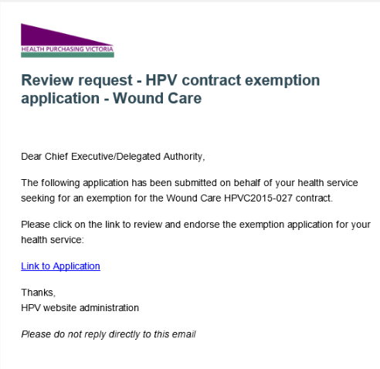
As the nominated CEO/delegated authority for your health service, you will receive an email from noreplyhpv@healthsharevic.org.au which contains a link to a contract exemption application submitted by a member of your health service. The subject of this email is “Review request – HSV contract exemption application – [Contract Name]”.
To endorse an exemption application:
- Click on the Link to Application link in the email to open the application
- Review the submitted application
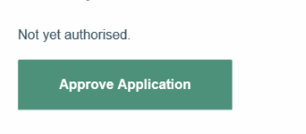
- Click on Approve Application to approve the application

To reject an exemption application:
- Click on the Link to Application link in the email to open the application
- Review the submission
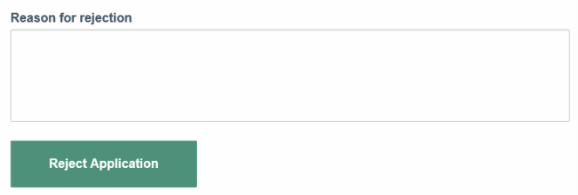
- Add a reason for the rejection and click Reject Application to reject the application

An email will be sent to the contact person of the application advising them outcome. If the application was rejected, the applicant will have the opportunity to update the application and re-submit for endorsement.

Re-sending an application for endorsement
To resend your application to the nominated health service CEO/delegated authority for endorsement:
- Login to the Exemptions Portal on the HSV website
- Click on the contract name of the application you wish to resend for endorsement
- Scroll to Part 4 of the application form and click edit to open the form
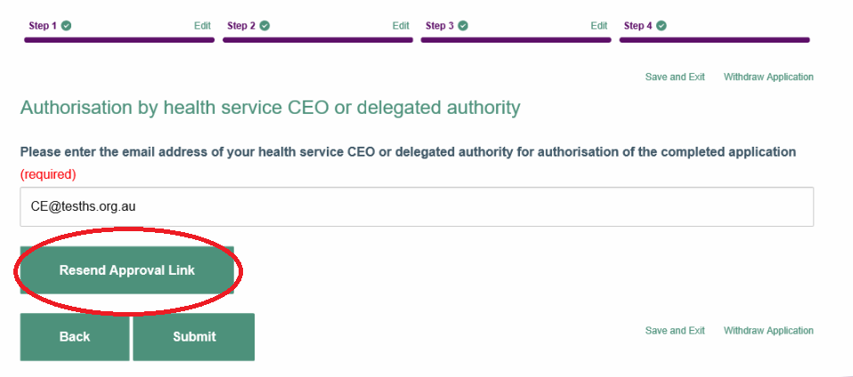
- Click the resend approval link button to resend the endorsement request to the nominated health service CEO/delegated authority

You will receive a notification once your nominated CEO/delegated authority has actioned the request.

Accessing your existing applications
A summary of the exemption applications for your health service will be displayed on the landing page of the portal. The applications will be displayed with the most recent on top.
Click on the contract name to view the application.
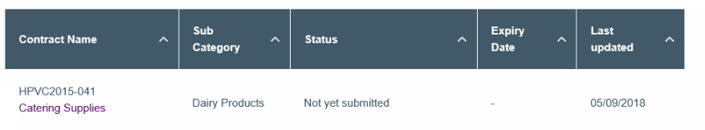
If your application is missing from this list, please contact your Customer Relationship manager or HPV via helpdesk@healthsharevic.org.au

Application status
Exemption applications in the portal will have one of the following statuses.
Status | Definition
Not yet submitted | The application has been created but not yet submitted to the CEO/delegated authority for endorsement or application has been rejected by the nominated CEO/delegated authority
Awaiting health service CEO endorsement | The application has been submitted to the health service CEO/delegated authority for review but has not yet been endorsed
Received and under review | The application has been submitted and is pending HPV’s review
More information required | The application has been reviewed by HSV and more information is required to support the application
Interim approved | An Interim exemption has been approved for the nominated contract
Approved | The application has been approved by HSV. Health service is exempt from purchasing off the nominated contract
Rejected | The application has been rejected by HSV. Health service to continue purchasing from the nominated contract
Withdrawn | The application has been withdrawn by your health service
Expired | The approved exemption for the nominated contract has expired

Assessment of the application
Following the endorsement of the application by the health service CEO/delegate, the application will then be submitted to HSV for review. The review and assessment of your application will be undertaken by a member of HSV’s procurement team.
If more information is required to support your application, you will notified by HSV and asked to provide additional information via the existing application form in the Exemptions Portal.

Responding to more information requests
If you have been asked to provide more information for your application, you will receive an email from noreplyhpv@healthsharevic.org.au notifying you of this request.
To respond to the request for more information:
- Login to the Exemptions Portal on the HSV website
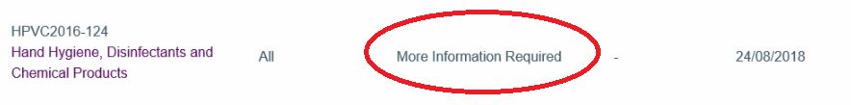
- Click on the contract name of the application where the status is set to More Information Required
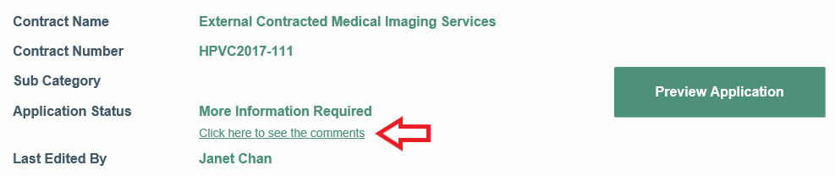
- Click on the link below the application status to scroll to the More Information Comments section at the bottom of the application form and review the comments provided by HSV
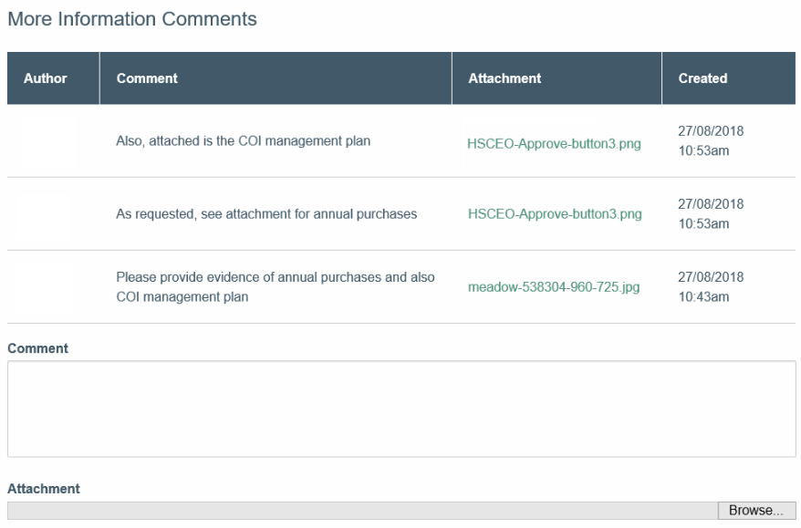
- Provide your response in the comments field and add an attachment (if required)
- Click submit to submit the response to HSV

Withdrawing an application
To withdraw an existing exemption application:
- Login to the HSV website to view your existing exemption applications in the Portal
- Click on the contract name of the application you wish to withdraw
- Once the Exemption opens, click the green button for ‘Preview Application’
- Once the Application opens, scroll to the bottom the page and on the far-right hand side is ‘Withdraw Application’
- Click the Withdraw Application link to withdraw your application
- Provide a reason for the withdrawal (optional) and click Withdraw Application to complete the withdrawal
The status of the application will now have been set to Withdrawn. You will also receive a confirmation email for your records.

Exemption expiry
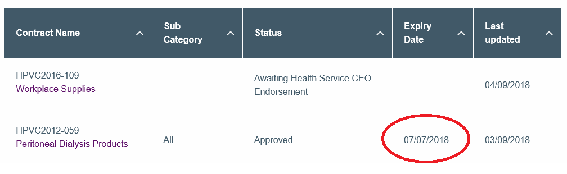
Exemptions approved by HSV are issued for a specific period. The expiry date of a contract exemption is shown in the summary table on the Exemptions Portal landing page. This table enables you to track the expiry date to plan and re-assess whether an additional request is warranted at that time.
The contact person listed against a contract will be notified by email of:
- The upcoming expiry of an existing contract exemption, one month prior to expiry date
- The expiry of an exemption once the expiry date has been exceeded

Support
For any queries relating to the submission, please contact your Customer Relationship Manager (CRM) or email helpdesk@healthsharevic.org.au

