HealthShare Victoria
Graduated Compliance Guidelines

8 October 2020

Version 2.0

Author | Danielle Head
Version | 2.0
Implementation | June 2019
Next review | October 2021
Approval | Finance, Risk and Governance
Data Classification | Public

Public
CONTENTS

Introduction ....................................................................................................................................................................... 4

Purpose............................................................................................................................................................................... 4

Background ......................................................................................................................................................................... 4

Compliance Framework ...................................................................................................................................................... 5

A graduated compliance approach.................................................................................................................................. 6

Graduated compliance values............................................................................................................................................. 6

Graduated compliance model ............................................................................................................................................. 6

Compliance information and support............................................................................................................................ 11
Introduction

Purpose

These guidelines outline the methodology applied by Health Purchasing Victoria (HPV) in determining its response to non-compliance against the Health Services Act 1988 (Vic) and supporting purchasing policies1. HPV’s graduated approach provides a framework which champions considered and measured responses to compliance issues.

Background

HPV is an independent public entity established under section 129 of the Act and is responsible to the
Minister of Health, working closely with the Department of Health and Human Services (DHHS).

Section 131 of the Act specifies HPV’s functions, and those relevant to our compliance work program include:

• Monitoring public health service compliance with purchasing policies and HPV directions and reporting irregularities to the Minister.
• Ensuring probity is maintained in purchasing, tendering and contracting activities in public hospitals
and public health services.
• Providing advice, staff training and consultancy services in relation to the supply of goods and services to, and the management of disposal of goods by, health or related services other than public hospitals.

On 26 June 2014, HPV introduced five new health purchasing policies (HPPs) in support of its statutory functions. The HPPs provide the strategic framework for health services to ensure best-practice procurement, including probity.

HPV has developed the following probity principles for procurement:

• Consistency and transparency of procurement processes.
• Fairness and impartiality in conducting procurement processes.
• Identifying and managing conflicts of interest.
• Security and confidentiality of documents and information.
• Ensuring market equality.
• Allocating appropriate capability.

The good procurement practices that HPV promotes ultimately benefit all Victorians by advancing improved patient care and high-quality, financially-sustainable procurement outcomes.

Subsection 134(3) of the Act specifies that a public hospital must comply with each purchasing policy to the extent that it applies to the public hospital. The term ‘public hospital’ is defined under the Act, but broadly includes hospitals and public health services listed at Schedule 1 and 5 of the Act2. HPV refers to these health services as ‘mandated’ health services.
It is HPV’s position that mandated and eligible health services are ultimately responsible for understanding and meeting their requirements under the Act, the HPPs and relevant HPV directions in force.

1 In accordance with subsection 134(1) of the Act, HPV has the power to prepare, make, amend and revoke instruments (known as health purchasing policies) with respect to policies and practices (including probity) relating to the supply of goods and services to public hospitals and the management and disposal of goods by public hospitals. Health service compliance with these purchasing policies is a requirement under subsection 134(3) of the Act.
2 It is noted that the definition includes some limitations for the applicable health services.
Compliance Framework

The Compliance Framework forms the foundation of HPV’s compliance-related activities, and is informed by HPV’s functions under the Act and the health service reporting requirements specified in Health Purchasing Policy 1: Procurement Governance. This framework outlines three focal areas for HPV’s compliance program:

1. Support and prevention
HPV is committed to providing health services with the support, guidance and education to strengthen their ability to comply with the requirements of the HPPs and ensure that probity is maintained in health service procurement activities.

2. Compliance monitoring
HPV has a legislated responsibility under subparagraph 131(d) of the Act to monitor health service compliance with the HPPs and applicable HPV directions in force. This monitoring function is achieved through a number of health service reporting requirements, detailed further in the Health Purchasing Victoria: Health Service Reporting Guidelines.

The reporting submissions that health services make are an essential information gathering tool for HPV and help to inform the appropriate compliance response required while contributing to the development of future compliance priority initiatives.

3. Compliance priorities
HPV will develop and implement a compliance priorities program which champions tailored initiatives to patterns of non-compliance. This strategic goal is detailed further in the Health Purchasing
Victoria: Compliance Strategy 2019-2022.

The Compliance Strategy and other supporting guidelines complement the Compliance Framework.

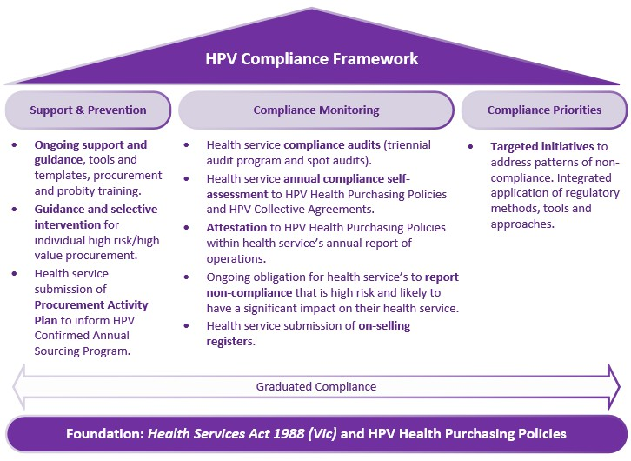
A graduated compliance approach

HPV’s graduated compliance approach encourages measured and appropriate responses to compliance
issues identified in health service reporting submissions or by other HPV information-gathering tools. Through its implementation, the graduated compliance approach:
• Encourages the lowest level of intervention – such as education and support – in response to issues
of non-compliance.
• Recognises the capacity of health service(s) to become compliant.
• Promotes compliance action proportionate to the level of risk.
• Provides sufficient flexibility to escalate or de-escalate compliance action if required.
• Champions an evidence-based decision-making process.
• Considers the behaviour and compliance history of the health service.

HPV operationalisese this approach through graduated compliance values and the graduated compliance model.

Graduated compliance values

The following values provide a basis for the graduated compliance approach and are an extension of HPV’s
organisational values, listed below in bold text.

We are customer-focused

• We consider the implications of our compliance decisions and their resource requirements on health services.

We keep it simple

• Our compliance response is measured and proportionate to the risk.

We are collaborative

• We partner with and support health services to encourage compliance.

We take responsibility

• Our consideration of compliance issues and decision-making process is transparent and based on relevant facts.

We inspire confidence

• We do the right thing. We are open, honest and trustworthy. We aim to deliver best-value procurement outcomes.

The graduated compliance model

The graduated compliance model is used when assessing and deciding upon an appropriate course of action to reported or identified non-compliance against the HPPs or the Act.

The model operates by applying key assessment criteria on a case-by-case basis to instances of non- compliance or by taking a holistic approach to a health service’s reporting submission. HPV’s approach of weighing and balancing key criteria supports decision-making in a way that leads to more consistent compliance responses.

The model comprises four hierarchical layers:
• Education and support.
• Administrative action.
• HPV direction.
• Report to the Minister.

The model’s multi-layer aspect ensures HPV has the flexibility to tailor our response to the circumstances of each matter under consideration, while providing the ability to escalate or de-escalate as required. Together, these layers and the model’s pyramid structure reflect HPV’s overall compliance approach.

The model promotes lower levels of intervention – such as education and support – which is HPV’s preferred approach to compliance issues. However, where a stronger response is required and supported by HPV’s analysis process, the model provides a clear escalation path. The implications of HPV’s compliance
decisions and the resource requirements on health services is at the forefront of our decision-making
process in line with the graduated compliance values discussed earlier.

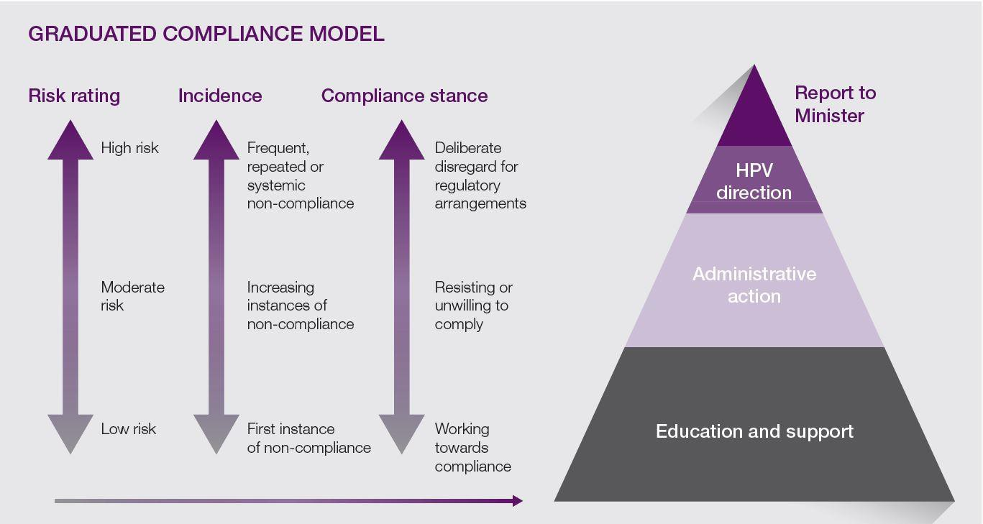

Applying the model

In determining which layer of response is appropriate to the matter under consideration, HPV will:

1. Conduct a risk assessment (Risk rating). This risk assessment may be applied to an individual instance of non-compliance or to the overall outcome of a health service compliance report submission. Without limiting HPV’s risk assessment process, the analysis may include consideration
of:

• HPV’s Compliance Assessment Tool3.
• The risk rating nominated by the health service and/or its auditor, if relevant.
• The accepted level of risk for the health service, if communicated to HPV.
• The extent of the compliance issues identified, and/or
• The purchasing size of the health service.

2. Consider whether the non-compliance is recurring or the first reported instance (Incidence). This analysis includes consideration of the health service’s compliance history and the results of previous

3 Refer to the Health Purchasing Victoria Audit Program Guidance Notes.
reporting submissions. While most matters are considered on a case-by-case basis, the health service’s compliance history may inform the progress made towards achieving compliance or indicate systemic compliance issues in which a stronger HPV response may be required.

3. Consider the health service’s compliance standing (Compliance stance). The health service’s disposition to the requirements of the Act and HPPs generally will inform this assessment. Indicators of a poor compliance standing may include disengagement or failing to act in good faith with HPV’s reporting requirements (i.e. a pattern of late submissions for health service reporting, recurrence of non-compliance issues).

A health service’s compliance standing is particularly relevant when HPV is deciding whether to escalate or de-escalate its response. HPV may initially respond with an educational or supportive approach, but choose to escalate if the health service fails to demonstrate that it is working towards compliance and the decision to take stronger action is supported by a high inherent and residual risk rating.

A health service’s audit report and subsequent findings are assessed holistically by HPV. If an ‘education and support’ response is considered appropriate, HPV will assist the health service to achieve compliance and continue to monitor and seek advice on the completion of health service recommendations for medium- or high-risk audit findings. Depending on the outcome of this interaction (compliance standing), and the risk of the matter under consideration (risk rating), HPV may decide to escalate its compliance response.

Compliance responses

The graduated compliance model exhibits four hierarchical layers for HPV’s compliance response, which is tailored to the circumstances of each case or broader issue under consideration.

These broad categories are characteristic of the seriousness of the issue(s) being considered and level of intervention required. The layers and the various actions that may be implemented are detailed below. This guidance should not be treated as an exhaustive list.

In the interest of procedural fairness, HPV will inform the health service of our assessment and provide an opportunity to respond before taking further action. HPV reocognises that procedural fairness promotes good governance and a fair decision-making process.

To assist health services to understand the application of the graduated compliance model, a number of
scenarios are provided below with HPV’s analysis broadly described.

Education and support

HPV’s preference is to support health services to achieve compliance through cooperative measures. HPV
support may include the following tools:

• Tailored advice and support from HPV’s Customer Relationship Managers.
• Educational tools, resources and templates.
• Increased sector advice on the subject matter through HPV’s communication channels.
• HPV online training, where broader health service education is required.
• Collaboration with other government departments.

HPV’s compliance response under this layer may include one or a combination of educational tools.

Scenario 1

Yarra Health Service has submitted its annual self-assessment of compliance to the HPPs and HPV collective agreements. The health service has identified that it is partially compliant to Health Purchasing Policy 2: Procurement Strategic Analysis and detailed the reasons for this compliance rating and the actions it will take to rectify issues in the form comments. Otherwise, the health service is fully compliant to all HPV collective agreements and HPPs.

The Health Purchasing Victoria: Health Service Reporting Guidelines state that a partial compliance assessment means the health service has demonstrated it has achieved compliance for 75 per cent or more of the HPP.

This is the first instance of non-compliance for the health service, which has demonstrated it is working towards compliance. HPV determines that the risk, incidence and compliance standing of the health service supports an educational and supportive response.

During their next one-on-one session with the health service, a HPV Customer Relationship Manager discusses the outcomes of the self-assessment with the health service and recommends a number of
HPV education resources.

Administrative action

HPV’s compliance responses under the ‘Administrative action’ layer are firmer than in the lower tier and in direct proportion to the increased risk of the matter(s) under consideration. Cooperative measures for achieving compliance are promoted where the assessment is at the bottom end of the layer (i.e. near education and support). Stronger responses will be considered if further escalation is likely or the assessment process results at the top end of the layer (i.e. near HPV direction).

Informed by the circumstances of the matter under consideration, HPV’s compliance response may include:

• Tailored advice and support from HPV’s Compliance Team.
• Seeking confirmation of health service fulfilment of audit recommendations and/or agreed actions.
• Escalation within HPV (i.e. Director of Finance, Risk and Governance or HPV Chief Executive).
• Exercise of power under subparagraph 132(e) of the Act, requiring the health service to provide information and data relating to the supply of goods and services.
As illustrated in the graduated compliance model, the majority of compliance issues considered by HPV will be captured in the bottom two layers of the pyramid.

Scenario 2

HPV has assessed the Maribyrnong River Health Service’s audit report and auditor findings. The audit report notes a number of medium-risk issues. Some of these audit issues had been identified in previous compliance reporting, in which HPV had adopted an educational and supportive approach
based on our assessment at the time. However, the audit report outcomes have identified that the health service has failed to rectify these compliance issues as previously advised.

After conducting our assessment, HPV recommends a response of administrative action. In HPV’s letter of response to the health service, HPV’s Chief Executive advises of the outcomes of HPV’s assessment under the graduated compliance model and that implementation of the audit recommendations will be followed up by HPV’s Compliance Team.

The HPV Compliance Team subsequently makes contact with the health service’s Chief Procurement Officer to request that status reports be provided on the implementation of audit recommendations, in line with the timeframes nominated by the health service in the audit report. The health service emails the team as these recommendations are actioned.
HPV direction

The ‘HPV direction’ layer is considered a serious response to non-compliance. In accordance with subparagraph 132(2)(c)(ii) of the Act, HPV has the power to give written directions to one or more public hospitals to ensure that probity is maintained in purchasing, tendering and contracting activities.

This written direction outlines:

• The outcomes of HPV’s assessment under the graduated compliance model.
• The probity requirements which have been compromised or are at significant risk.
• Actions required of the health service under the direction and associated timeframe(s).

Subsection 132(3) of the Act provides that a HPV direction must be complied with, unless it is inconsistent with a contract entered by that hospital before HPV gave that direction.

Spot audit

Exercise of power under subparagraph 132(2)(d) requiring a spot audit to be conducted.

HPV does not take a decision to conduct a spot audit lightly and will only consider this response if we have significant concerns or grounds for further escalation. A spot audit would be treated as an information- gathering tool rather than a measure for encouraging compliance. Triggers for conducting a spot audit may include:

- Significant irregularities with the health service’s compliance reporting submissions.
- Evidence to support systemic non-compliance within the health service.
- Any other information that HPV receives which raises serious concern about a health service’s
compliance with the HPPs (i.e. protected disclosures or media investigations).

Report to the Minister

HPV’s functions under the Act include the requirement to monitor compliance by public hospitals with purchasing policies and HPV directions, and to report irregularities to the Minister4. While HPV has this legislated responsibility, it will only report health service non-compliance to the Minister in the most serious of cases. HPV’s reporting to the Minister will be conducted via the Department of Health and Human Services.

This layer includes consideration and potential referral to the Independent Broad-based Anti-corruption
Commission, Victorian Ombudsman or other relevant department for further investigation.

4 Subsection 131(d) of the Act refers.
Compliance information and support

Contact for further

HPV’s Compliance Team can be contacted at compliance@hpv.org.au.

Complaints

HPV has formal mechanisms in place to investigate complaints from organisations including mandated health services, suppliers and other stakeholders. The HPV Complaints Management Procedure details the process for submitting a complaint to HPV. HPV manages any complaint submitted in accordance with this Policy.

